

Fortnightly Progress Report

SIDBI – PMU Chhattisgarh

Period – 1st to 15th January 2023

**Project Progress Report – Fortnightly**

|  |  |
| --- | --- |
| **SIDBI State PMU – MSMEs** | |
| **Location: Chhattisgarh**  **Month & Year: January 2023**  **Fortnight Ending: 15th January 2023** | **Report Summary**  This Report includes the activities carried out by SIDBI - PMU for the  facilitation of MSME Ecosystem in the State of Chhattisgarh. |

**Team Deployment Status**

|  |  |  |  |
| --- | --- | --- | --- |
| **Team** | | | |
| **SN** | **Designation** | **Name of Resource** | **Deployment Date** |
| 1 | PMU Manager | Ishwar Kumar | 08th August 2022 |
| 2 | Business Analyst | Shubham Jha | 07th November 2022 |

**Details of State Nodal Connect - Name – Shri Anil Tuteja (IAS), Director Industries, Chhattisgarh.**

**Shri Sanjay Gajghate, Joint Director Industries, Chhattisgarh.**

**Activities performed by PMU during fortnight ending 15th January 2023**

|  |  |
| --- | --- |
| **Activity** | **Details of activities carried out** |
| 1. PMU has followed up with Directorate of Institutional finance and Finance Department for conducting meeting on SCDF regarding-   a) Signing of Master Agreement between SIDBI and CG Government  b) Status of Article 293 (3)  c). conduct of Interdepartmental meeting on SCDF | |
| 1. PMU had conducted a meeting with Additional Director Sericulture and Handicrafts regarding the prospects for infrastructure development related Kosa Silk and Formation of a Silk Park in Chhattisgarh to showcase the value chain related to Kosa. In this regard, the PMU team also visited Silk Development Centre at Charama, Kanker to explore prospects for establishment of Silk Park as well as understand the possibility of developing a raw material bank for Kosa Silk in Chapa district. | |
| 1. PMU team approached the Rice Mill Units of Dhamtari for solar power installation through SIDBI Green Energy Financing. | |
| 1. PMU team held discussions with Naya Raipur Development Authority regarding convergence of SCDF fund in Infrastructural projects like development of Retail hub in Naya Raipur | |
| 1. PMU team held meeting with the president of Jewelry Association, Raipur regarding Raw material bank and Gems and Jewelry cluster development. | |
| 1. PMU arranged virtual meeting of Invoice Mart, RXIL and M1exchange with Additional Director-Directorate of Institutional Finance regarding discussion on onboarding of CG Govt. Departments/Corporations. | |
| 1. PMU approached the Joint Director Industries and requested to write an advisory note to industry associations, MSME support institutions and CREDA to invite resource persons from SIDBI regarding creating awareness about SIDBI Green Energy Financing. | |

|  |
| --- |
| **Actionable and Support required** |
|  |
| **Activities Way forward** |
| * Signing of Master Agreement for SCDF * Identify clusters for MSE CDP Scheme intervention * Work on State Export Document |
| **Inputs of State Nodal Connect / Officer** |
|  |

*****************

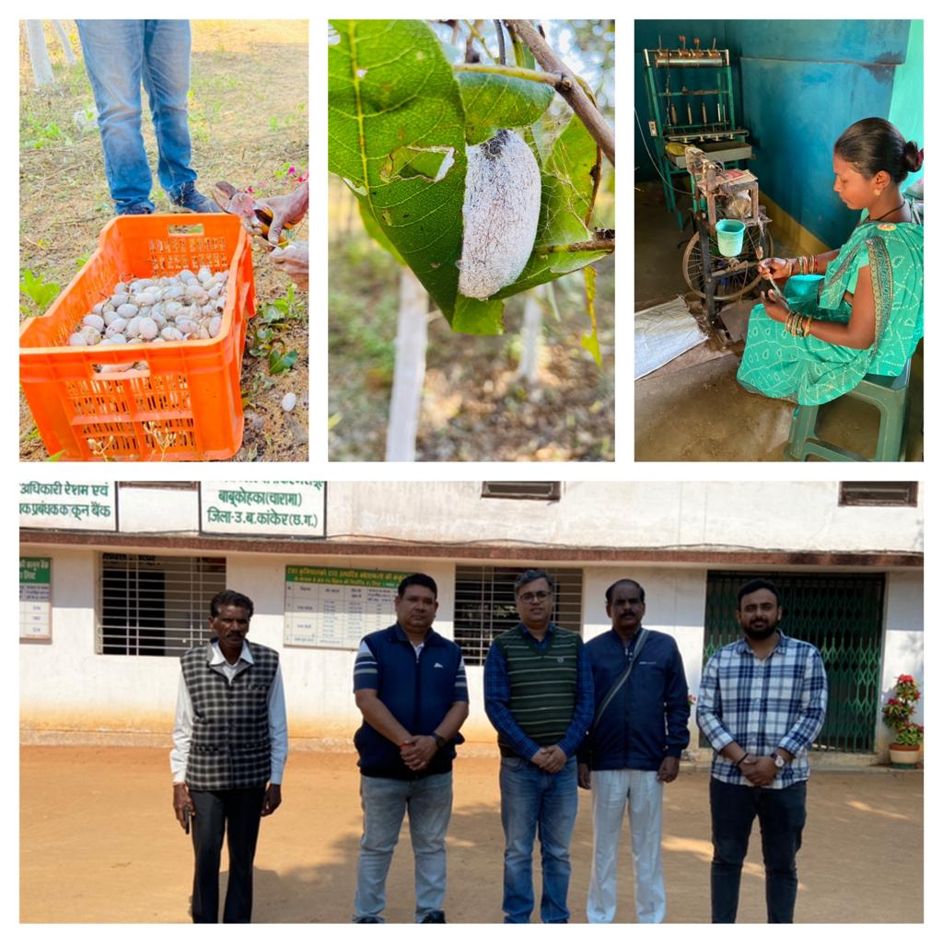

PMU team visit at Silk Development Centre

**Contact us**

To know more, please visit [**www.grantthornton.in**](http://www.grantthornton.in/) or contact any of our offices as mentioned below:

|  |  |  |  |  |
| --- | --- | --- | --- | --- |
| **NEW DELHI**  National Office, Outer Circle, L 41, Connaught Circus, New Delhi - 110001 T +91 11 4278 7070 | **NEW DELHI**  6th Floor, Worldmark 2, Aerocity,  New Delhi - 110037 T +91 11 4952 7400 | **AHMEDABAD**  7th Floor, Heritage Chambers,  Nr Azad Society, Nehru Nagar, Ahmedabad - 380015 | **BENGALURU**  5th Floor, 65/2, Block A, Bagmane Tridib, Bagmane Tech Park, CV Raman Nagar, Bengaluru - 560093  T+91 80 4243 0700 | **CHANDIGARH**  B-406A, 4th Floor, L&T Elante Office Building, Industrial Area Phase I, Chandigarh - 160002  T +91 172 4338 000 |
| **CHENNAI**  7th Floor, Prestige Polygon,  471, Anna Salai, Teynampet, Chennai - 600018  T +91 44 4294 0000 | **DEHRADUN**  Suite No 2211, 2nd Floor, Building 2000, Michigan Avenue, Doon Express Business Park,  Subhash Nagar, Dehradun - 248002  T +91 135 2646 500 | **GURGAON**  21st Floor, DLF Square, Jacaranda Marg, DLF Phase II,  Gurgaon - 122002  T +91 124 462 8000 | **HYDERABAD**  7th Floor, Block III, White House,  Kundan Bagh, Begumpet, Hyderabad - 500016  T +91 40 6630 8200 | **KOCH**I  6th Floor, Modayil Centre Point, Warriam Road Junction, MG Road Kochi - 682016  T +91 484 406 4541 |
| **KOLKATA**  10C Hungerford Street, 5th Floor,  Kolkata - 700017  T +91 33 4050 8000 | **MUMBAI**  11th Floor, Tower II,  One International Center, SB Marg Prabhadevi (W), Mumbai - 400013  T +91 22 6626 2600 | **MUMBAI**  Kaledonia, 1st Floor, C Wing, (Opposite J&J Office),  Sahar Road, Andheri East,  Mumbai - 400 069 | **NOIDA**  Plot No 19A, 2nd Floor, Sector - 16A,  Noida - 201301  T +91 120 485 5900 | **PUNE**  3rd Floor, Unit No 309- 312, West Wing, Nyati Unitree, Nagar Road, Yerwada  Pune - 411006  T +91 20 6744 8800 |

For more information or for any queries, write to us at [**contact@in.gt.com**](mailto:contact@in.gt.com)

|  |  |
| --- | --- |
| Twitter-outline | **Follow us @GrantThorntonIN** |

**Small Industries Development Bank of India (SIDBI),** established under an Act of Parliament in 1990, acts as the Principal Financial Institution for Promotion, Financing and Development of the Micro, Small and Medium Enterprise (MSME) sector as well as for co-ordination of functions of institutions engaged in similar activities. In the context of the changing MSME lending landscape, the role of SIDBI has been realigned through adoption of SIDBI Vision 2.0 which envisages an integrated credit and development support role of the Bank by being a thought leader, adopting a credit-plus approach, creating a multiplier effect and serving as an aggregator in MSME space.





***Disclaime****r: This document is prepared under SIDBI intervention in which Grant Thornton Bharat LLP is the implementing agency. The document users/third parties shall verify the facts and figures at their end and shall be solely liable for any action taken by it based on this document. SIDBI, its directors, employees or any office shall not be liable for loss of whatsoever nature arising by using the content of this document.*